What is the Harbor Bridge project?
The proposed project would replace the Harbor Bridge and approach roadways over the Corpus Christi Ship Channel. and reconstruct the I-37/Crosstown Expressway interchange. The new Harbor Bridge would remain six lanes (3 lanes in each direction with shoulders) and not add new travel lanes on the bridge or approach roadways.

What agencies involved in the project development?
- Federal Highway Administration is the lead Federal agency for the project
- TxDOT is the joint lead agency
- U.S. Environmental Protection Agency (EPA), U.S. Coast Guard (USCG) and U.S. Department of Housing and Urban Development (HUD) are Cooperating agencies for the project

Why is this project needed?
- Maximize long-term highway operability of the US 181 crossing of the Corpus Christi Ship Channel:
- Be designed with non-corrodible materials (such as concrete) requiring less maintenance over the life of the structure (75-100 years)
- Not be designed as a fracture-critical structure (does not have back-up structural elements to carry loads if a single support fails)

- Improve safety for the public who travel on US 181 and to establish a reliable, long-term hurricane evacuation route:
- Providing shoulders
- Reducing the vertical grade and horizontal curvature
- Improving entrance and exit ramp access
- Design that meets the State’s standards for hurricane evacuation

What are the objectives in addition to the need for the project?
- Provide transportation infrastructure to support future economic opportunities in the Coastal Bend
- Consider the connectivity of US 181 to the local roadway system and address its effect on the adjacent neighborhoods

What are the alternatives studied?
Four alternatives - Green, Red, Orange, West and the no-build alternative - were equally evaluated to determine how well each addressed the project’s needs and minimized impacts to the community and environment. The Red Alternative has been identified as the preferred alternative in the Draft EIS.

What is the next step?
Public comment period: January 3, 2014 – March 18, 2014

Public hearing: February 18, 2014 from 5 – 8 p.m. at the Congressman Solomon P. Ortiz International Center (402 Harbor Drive). After comments are received and evaluated, the final Environmental Impact Statement and Record of Decision will be prepared and submitted.
What is an Environmental Impact Statement (EIS)?
Must be approved by the Federal Highway Administration with a Record of Decision before right-of-way can be purchased and construction can begin.

Includes public involvement at beginning of EIS development and throughout the environmental process.

Discloses project information, describes the project and study areas, and analyzes possible environmental consequences associated with building the project.

An environmental document required by the National Environmental Policy Act for large construction projects that use federal highway funds.

How can I comment or learn more about the project?

Mail your comments to:
Christopher Amy, TxDOT Corpus Christi
1701 S. Padre Island Dr.
Corpus Christi, Texas 78416

On the website at
ccharborbridgeproject.com
Or via email
www.harborbridgeDEIS.com




Attend the neighborhood meetings
(times and locations available on the website)
Request a meeting for your group or organization

For more information, contact:
- TxDOT Project Manager/Engineer, Victor E. Vourcos P.E. (361) 808-2378
- TxDOT Project Manager/Environmental Coordinator, Christopher Amy, (361) 739-6960
Ends (3/18/14)
Begins (1/3/14)
CAC/TAC Meetings (1/9/14)
Public Hearing (2/18/14)
Public Comment Period
FEIS/Record of Decision
Construction
Neighborhood Meetings
MARCH 2014
JANUARY 2014
FEBRUARY 2014
FALL 2014
2015
Week 3
Week 1
Week 1
Week 2
Week 2
Week 4
Week 3
Week 4
Week 1
Harbor Bridge Project Timeline

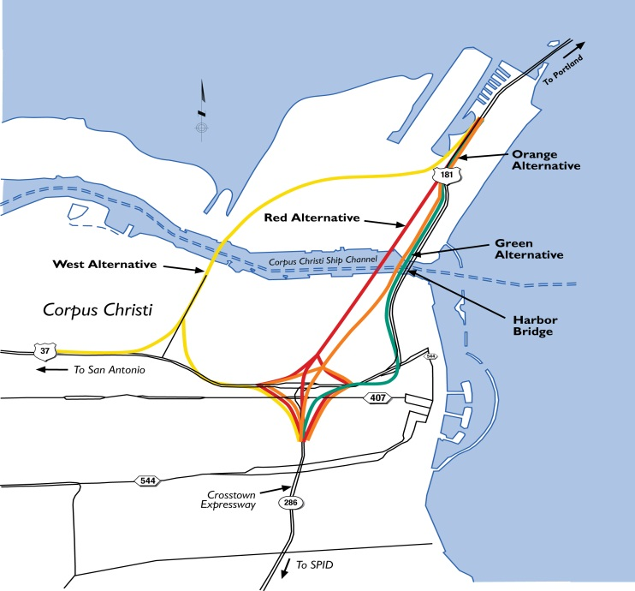
Map that roughly depicts the project study area and the four alternatives studied in the Draft EIS document.
2015
Phased Construction

